Experiment No-04
Study of CMOS OR Gate Schematics in Cadence Virtuoso Software
1.1 Objectives
The main objectives of this experiment are summarized as:
- To understand the concept and operation of a two-input CMOS OR gate as a fundamental building block of digital logic circuits.
- To become familiar with the Cadence Virtuoso schematic editor and the standard IC design flow used to create standard cells.
- To design the transistor-level schematic of a two-input CMOS OR gate, implemented as a NOR stage (two series PMOS transistors as the pull-up network and two parallel NMOS transistors as the pull-down network) followed by a CMOS inverter stage, using devices from the gpdk090 technology library, and to generate its schematic symbol.
- To construct a test bench for the OR gate, with two independent pulse sources at its two inputs, and verify its functionality through transient simulation using Spectre in the Analog Design Environment (ADE L).
- To obtain and analyze the transient input/output wave-forms of the designed OR gate for all combinations of its two input signals, and to verify them against the OR truth table.
Keywords- CMOS OR gate, NMOS, PMOS, Cadence Virtuoso, schematic editor, Spectre, NOR-inverter cascade, transient response, truth table, standard cell.
1.2 Theory
An OR gate is a fundamental digital logic gate whose output is the logical OR of its inputs. For a two-input OR gate with inputs A and B and output Y, the operation is expressed by the Boolean expression Y = A + B. The output is HIGH (logic 1) whenever at least one input is HIGH (logic 1), and LOW (logic 0) only when both inputs are LOW (logic 0). The truth table of an ideal two-input OR gate is shown in Table-1.1.
A | B | Y = A + B
0 | 0 | 0
0 | 1 | 1
1 | 0 | 1
1 | 1 | 1
Table-1.1. Truth table of an ideal two-input OR gate.
1.2.1 The CMOS OR Gate (NOR–Inverter Cascade)
Like the AND gate, a non-inverting OR function cannot be realized directly by a single stage of complementary CMOS transistors, because a purely complementary pull-up/pull-down network always produces an inverted output. A two-input CMOS OR gate is therefore built as a cascade of two stages: a first stage that is a standard two-input NOR gate, consisting of two PMOS transistors (PM0, PM1) connected in series between VDD and an internal node, and two NMOS transistors (NM0, NM1) connected in parallel between that internal node and VSS; and a second stage that is a CMOS inverter, consisting of one PMOS transistor (PM2) and one NMOS transistor (NM2), which inverts the internal NOR node to produce the final output Vout.
The internal node is pulled HIGH only when both series PMOS transistors of the first stage are simultaneously ON, which happens only when both A and B are LOW; for every other input combination, at least one of the parallel NMOS transistors is ON and pulls the internal node LOW. The inverter stage then inverts this internal node, so the final output Vout is LOW only when both A and B are LOW, and HIGH whenever at least one input is HIGH – the correct OR function. Because neither the NOR stage nor the inverter stage ever has its pull-up and pull-down networks both fully ON for the same static input combination, the static power dissipation of the overall CMOS OR gate is ideally zero, just as for the individual NOR and inverter stages.
1.2.2 Transistor Sizing and the Two-Stage Cascade
In contrast to the NAND stage of the AND gate, the series transistor stack of the NOR stage is in the pull-up network: the two PMOS transistors are connected in series, which gives the internal node a higher effective pull-up resistance than a single PMOS transistor of the same width would provide, tending to slow its LOW-to-HIGH transition. Because a PMOS device is already the weaker device for a given width, a series PMOS stack is generally the less favourable place for a stack. The second (inverter) stage, however, uses only a single PMOS and a single NMOS transistor, so it switches with the same speed characteristics as a standalone CMOS inverter and restores a full-swing, sharply-transitioning output at Vout.
Because the mobility of holes in a PMOS transistor is lower than the mobility of electrons in an NMOS transistor, a PMOS device must be made wider than an NMOS device of the same length to provide comparable drive strength. In this experiment, the same transistor dimensions used for the earlier CMOS inverter, NAND gate and AND gate designs were retained for all three PMOS and all three NMOS devices of the OR gate: every PMOS device (PM0, PM1, PM2) was sized with a total width of 720 nm, and every NMOS device (NM0, NM1, NM2) with a total width of 240 nm, for the same channel length of 100 nm, giving the same 3:1 PMOS-to-NMOS width ratio as before. Keeping these dimensions unchanged preserves consistency with the earlier experiments for both the NOR stage and the inverter stage, although the two series PMOS devices were not widened to compensate for the stack.
1.2.3 Cadence Virtuoso Design Flow
In this experiment, the CMOS OR gate is designed and verified using the Cadence Virtuoso IC design environment. The overall flow consists of creating a design library attached to a process technology library (gpdk090), drawing the transistor-level schematic in the Schematic XL editor by placing and sizing three PMOS and three NMOS instances and wiring them into a NOR stage followed by an inverter stage, generating a schematic symbol for the OR cell, and finally building a separate test bench schematic in which the OR symbol is instantiated along with two independent input sources and supply sources. The test bench is then simulated using the Spectre simulator inside the Analog Design Environment (ADE L) to verify the OR gate’s transient behaviour.
1.3 Hardware/Software Used for the Experiment
1. Cadence Virtuoso Schematic Editor (Schematic XL)
2. Virtuoso Analog Design Environment (ADE L)
3. Spectre circuit simulator
4. gpdk090 generic process design kit (technology library)
5. Three NMOS and three PMOS transistors (gpdk090_nmos1v, gpdk090_pmos1v)
6. Two pulse voltage sources (vpulse), a DC voltage source (vdc) and ground (gnd) from analogLib
7. Linux workstation running the Cadence design environment
1.4 Experimental and Simulation Analysis
A design library (OR_Gate) was created and attached to the gpdk090 technology library, and a schematic cellview (carried over from the earlier inverter template and therefore still internally named inverter) was modified within it to implement the two-input OR function. Three NMOS and three PMOS instances were placed in the schematic, sized as described in Section 1.2.2, and wired into a first NOR stage (PM0, PM1, NM0, NM1) followed by a second inverter stage (PM2, NM2), with two input pins (VinA and VinB), an output pin (Vout), and the VDD/VSS supply pins. A schematic symbol was then generated for the OR cell. A separate test schematic (inverter_test) was built in which the OR symbol was instantiated with two independent pulse sources at its two inputs and a DC supply and ground connected to its power pins, and the design was simulated in ADE L using the Spectre simulator. Each of these steps is illustrated below.
1.4.1 Transistor Sizing and Parameter Selection
The width and length of each transistor were set in the Add Instance window at the time of placement. As in the earlier inverter design, each NMOS transistor (NM0, NM1, NM2) was sized with a total width of 240 nm and a channel length of 100 nm, while each PMOS transistor (PM0, PM1, PM2) was sized with a total width of 720 nm and the same channel length of 100 nm, giving the 3:1 PMOS-to-NMOS width ratio discussed in Section 1.2.2. The parameter selection window used for setting the NMOS device dimensions is shown in Figure-1.1.
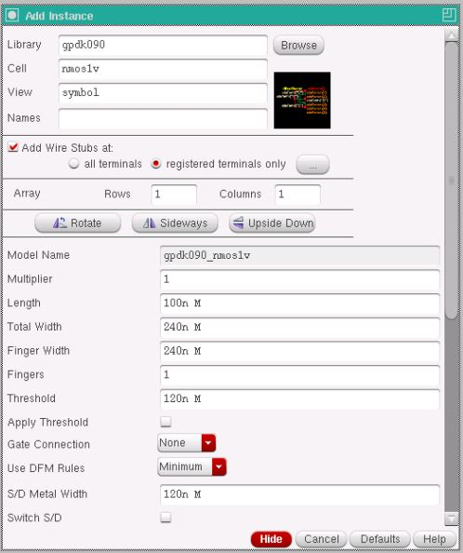
Figure-1.1. Add Instance window showing the width and length parameters set for the NMOS transistor (Total Width = 240n, Length = 100n).
Device | Width (W) | Length (L)
NMOS – NM0, NM1, NM2 (gpdk090_nmos1v) | 240 nm | 100 nm
PMOS – PM0, PM1, PM2 (gpdk090_pmos1v) | 720 nm | 100 nm
Table-1.2. Device parameters used for the NMOS and PMOS transistors in the OR gate schematic.
1.4.2 Transistor-Level Schematic of the CMOS OR Gate
The two PMOS transistors of the first stage (PM0, PM1) were connected in series between the VDD pin and an internal node, while the two NMOS transistors (NM0, NM1) were connected in parallel between that internal node and the VSS pin. The gates of PM0 and NM0 were tied together to form input A (VinA), and the gates of PM1 and NM1 were tied together to form input B (VinB). The internal node was then connected to the gates of the second-stage inverter transistors (PM2, NM2), whose drains were tied together to form the output net (Vout, labelled Output in the schematic), with PM2 connected to VDD and NM2 connected to VSS. The complete transistor-level schematic of the CMOS OR gate, with all pins and wires labelled, is shown in Figure-1.2.
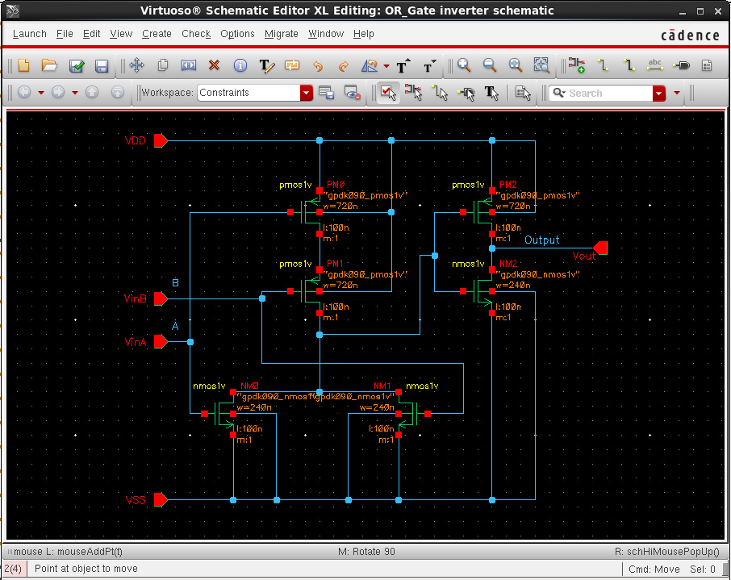
Figure-1.2. Complete transistor-level schematic of the CMOS OR gate, showing the first-stage NOR network (PM0, PM1 in series; NM0, NM1 in parallel) producing an internal node, and the second-stage inverter (PM2, NM2) that inverts this node to produce the final output Vout, with the VinA, VinB, Vout, VDD and VSS pins labelled.
1.4.3 Schematic Symbol Generation
After the schematic was checked and saved without errors, a schematic symbol was generated from the cellview using Create → Cellview → From Cellview, with VinA and VinB placed as the two left-side input pins, Vout placed as the right-side output pin, and VDD and VSS placed as the top and bottom pins. The default shape generated by Virtuoso was replaced with the conventional two-input OR symbol, a curved OR-gate body with a pointed output and no output bubble (distinguishing it from the NOR symbol), with the label OR placed at its centre, as shown in Figure-1.3.
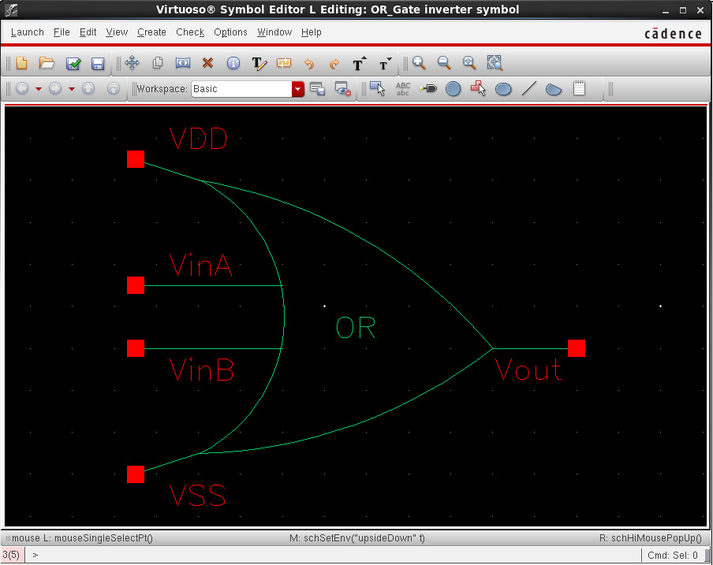
Figure-1.3. Generated schematic symbol of the CMOS OR gate, showing the two inputs VinA and VinB, the output Vout, and the VDD and VSS supply pins.
1.4.4 Test Bench Construction and Source Addition
A separate schematic, inverter_test, was created to verify the OR gate. The generated OR symbol was instantiated, and two independent pulse voltage sources (vpulse) from analogLib were connected to its two inputs: source V1 was connected to input A (VinA) with voltage1 = 0 V, voltage2 = 1.8 V, period = 20 ns and pulse width = 10 ns, while source V2 was connected to input B (VinB) with voltage1 = 0 V, voltage2 = 1.8 V, period = 40 ns and pulse width = 20 ns, so that all four input combinations of A and B are exercised over the course of the simulation. A DC voltage source (vdc) set to 1.8 V and a ground (gnd) were connected to the VDD and VSS pins respectively, and the input and output nets were named A, B and Output using Create → Wire Name. The completed test bench, with all sources added, is shown in Figure-1.4.
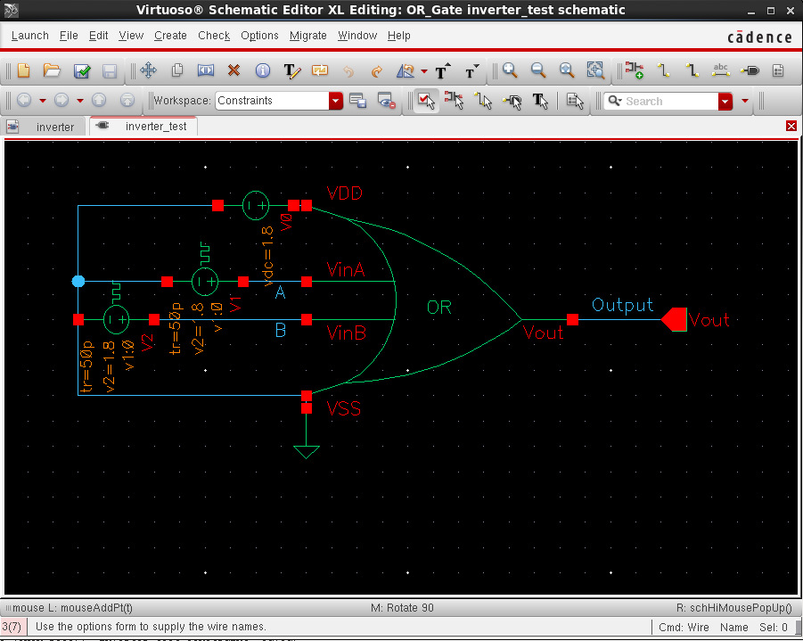
Figure-1.4. Test bench schematic (inverter_test) with the two pulse input sources V1 and V2, the DC supply V0, ground, and the OR symbol, with the A, B and Output nets labelled.
1.4.5 Input Source Parameter Selection
The Add Instance windows used to configure the two pulse sources and the DC supply are shown in Figure-1.5, Figure-1.6 and Figure-1.7. Figure-1.5 shows the parameters of source V1 driving input A, with Voltage 1 = 0 V, Voltage 2 = 1.8 V, a period of 20 ns, a pulse width of 10 ns, and rise/fall times of 50 ps. Figure-1.6 shows the parameters of source V2 driving input B, configured identically except for a longer period of 40 ns and a pulse width of 20 ns, so that B toggles at half the frequency of A. Figure-1.7 shows the Add Instance window for the vdc source used to set the VDD supply to a DC voltage of 1.8 V.
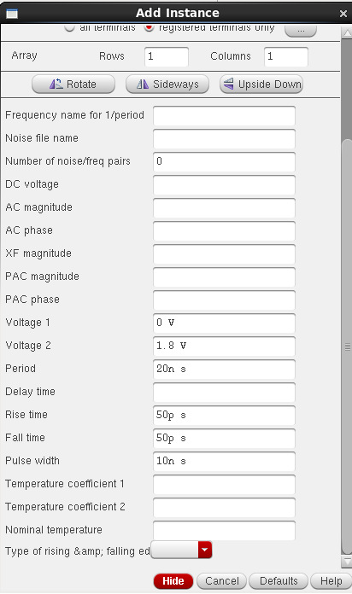 | 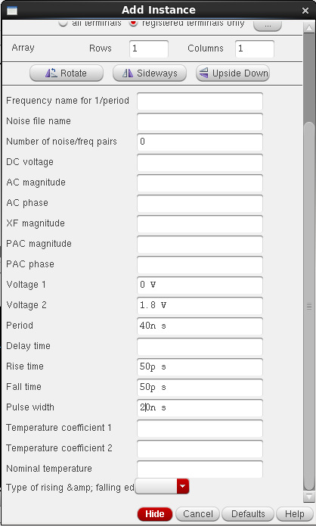
Figure-1.5. Add Instance window showing the pulse source V1 (OR gate input A): Voltage 1 = 0 V, Voltage 2 = 1.8 V, period = 20 ns, pulse width = 10 ns. | Figure-1.6. Add Instance window showing the pulse source V2 (OR gate input B): Voltage 1 = 0 V, Voltage 2 = 1.8 V, period = 40 ns, pulse width = 20 ns.
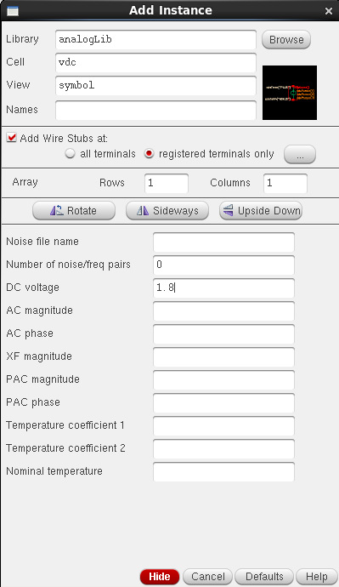
Figure-1.7. Add Instance window showing the vdc source used for the VDD supply, set to a DC voltage of 1.8 V.
1.4.6 Simulation Setup
The test bench was simulated in ADE L using the Spectre simulator, with the gpdk090 Spectre model library added under Setup → Model Libraries. A transient analysis was configured with a stop time of 200 ns so that several cycles of both the 20 ns-period input A and the 40 ns-period input B were captured. The input nets A and B and the output net Output were selected as the outputs to be plotted, and the simulation was run using Simulation → Netlist and Run.
1.4.7 Simulation Results: Input and Output Waveforms
Figure-1.8 shows the simulated transient response of the OR gate. The left-hand plot shows the two pulse inputs, A (top) and B (bottom), each switching between 0 V and 1.8 V, with A having a 20 ns period and a 10 ns pulse width and B having a 40 ns period and a 20 ns pulse width. The right-hand plot shows the corresponding output Vout (plotted as /Output) over a longer time axis that extends to about 110 ns. Together, the two inputs step through all four logic combinations in every 40 ns period: (A, B) = (1, 1) from 0 to 10 ns, (0, 1) from 10 to 20 ns, (1, 0) from 20 to 30 ns and (0, 0) from 30 to 40 ns, after which the pattern repeats. Consistent with the OR function, Vout is observed to be HIGH (about 1.8 V) during the first three intervals and to go LOW only when both inputs are LOW, from 30 to 40 ns and again from 70 to 80 ns, in direct agreement with the two-input OR truth table given in Table-1.1. At t = 0 the output starts at 0 V, since both inputs begin at 0 V, and rises to 1.8 V as soon as the inputs start to rise. The levels read from the waveforms are summarised in Table-1.3.
Time interval (ns) | A | B | Vout (observed)
0 – 10 | 1 | 1 | HIGH (1)
10 – 20 | 0 | 1 | HIGH (1)
20 – 30 | 1 | 0 | HIGH (1)
30 – 40 | 0 | 0 | LOW (0)
Table-1.3. Input and output levels read from the waveforms of Figure-1.8 for the first 40 ns period; the same four intervals repeat every 40 ns (for example, Vout is again LOW from 70 to 80 ns).
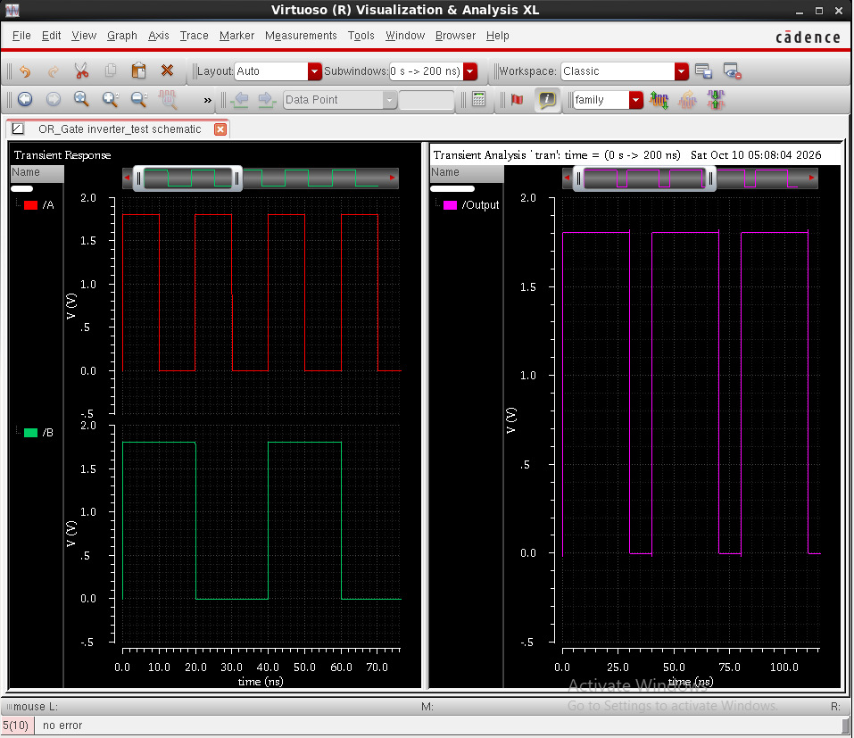
Figure-1.8. Simulation results: the two pulse inputs A and B (left) and the corresponding OR output Vout, plotted as /Output (right, on a longer time axis than the inputs).
1.5 Discussion
The simulated behaviour of the designed circuit was found to be in agreement with the theoretical operation of a CMOS OR gate described in Section 1.2. The transient simulation confirmed that the output Vout was LOW only during the intervals where input A and input B were simultaneously LOW (30 to 40 ns and 70 to 80 ns in the observed window), and HIGH otherwise, matching the expected truth table (Table-1.1). This confirms that cascading a two-input NOR stage with a CMOS inverter stage correctly restores the non-inverted OR function at the output. Because neither stage ever has its pull-up and pull-down networks both fully ON for the same static input combination, the circuit is also expected to dissipate negligible static power, consistent with the fundamental advantage of CMOS logic. Retaining the same transistor dimensions used for the earlier CMOS inverter, NAND and AND gate designs (WP = 720 nm, WN = 240 nm, L = 100 nm for all six devices) kept the design consistent with those experiments, although the series PMOS stack in the first stage is expected to make its internal LOW-to-HIGH transition somewhat slower than a single-transistor stage. The added inverter stage restores sharp output edges, and the stack did not affect the correctness of the final logical output observed in simulation; propagation delay was not measured in this experiment.
1.6 Conclusion
In this experiment, a two-input CMOS OR gate was successfully designed at the transistor level in Cadence Virtuoso, implemented as a two-input NOR stage (two series PMOS and two parallel NMOS transistors) cascaded with a CMOS inverter stage (one PMOS and one NMOS transistor), using devices from the gpdk090 technology library, and its schematic symbol was generated. A test bench was constructed with two independent pulse sources at the two inputs and a DC supply, and the circuit was verified through transient simulation using Spectre in ADE L. The observed input-output waveforms confirmed that the circuit correctly performs the logical OR operation, producing a LOW output only when both inputs were simultaneously LOW, consistent with the OR truth table. This experiment provided practical, hands-on experience with building a composite standard cell from two cascaded logic stages (NOR + inverter), which forms the basis for more complex digital and mixed-signal IC design in subsequent experiments.

